-- Inserting values into products table.

INSERT INTO Department values(newid(), 'Department1', 'Hospital@gmail.com', 'Oak 1')

INSERT INTO Department values(newid(), 'Department2', 'Hospital@gmail.com', 'Oak 6')

INSERT INTO Department values(newid(), 'Department3', 'Hospital@gmail.com', 'Oak 9')

INSERT INTO Department values(newid(), 'Department4', 'Hospital@gmail.com', 'Oak 4')

INSERT INTO Department values(newid(), 'Department5', 'Hospital@gmail.com', 'Oak 5')

INSERT INTO Department values(newid(), 'Department6', 'Hospital@gmail.com', 'Spruce 5')

INSERT INTO Department values(newid(), 'Department7', 'Hospital@gmail.com', 'Spruce 7')

INSERT INTO Department values(newid(), 'Department8', 'Hospital@gmail.com', 'Spruce 9')

INSERT INTO Department values(newid(), 'Department9', 'Hospital@gmail.com', 'Spruce 1')

INSERT INTO Department values(newid(), 'Department10', 'Hospital@gmail.com', 'Spruce

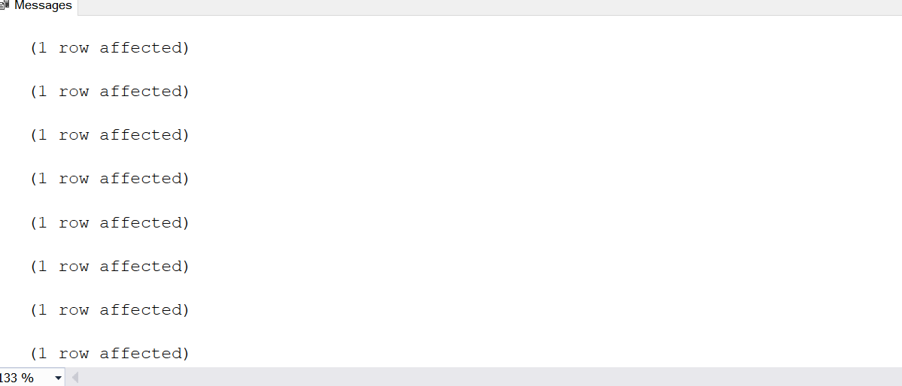2')

select\*from Department

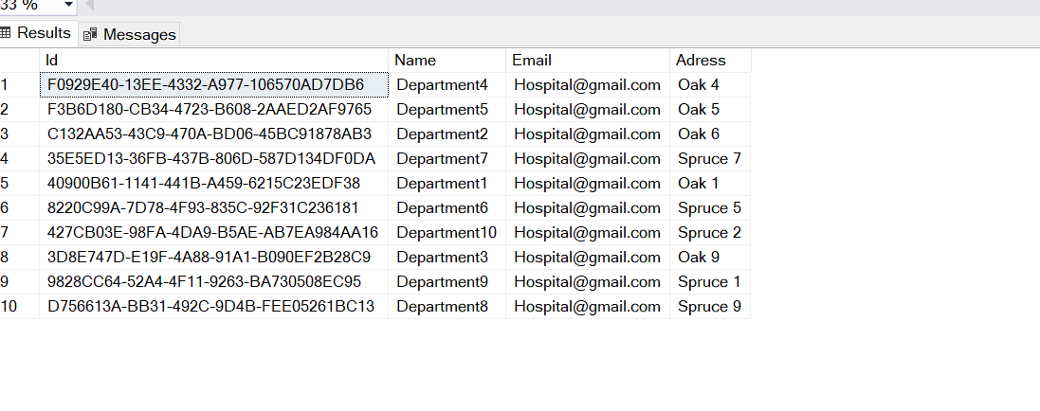

INSERT INTO Ward values(newid(), 4001, 'Hospital@gmail.com')

INSERT INTO Ward values(newid(), 4001, 'Hospital@gmail.com')

INSERT INTO Ward values(newid(), 4001, 'Hospital@gmail.com')

INSERT INTO Ward values(newid(), 4001, 'Hospital@gmail.com')

INSERT INTO Ward values(newid(), 4001, 'Hospital@gmail.com')

INSERT INTO Ward values(newid(), 4001, 'Hospital@gmail.com')

INSERT INTO Ward values(newid(), 4001, 'Hospital@gmail.com')

INSERT INTO Ward values(newid(), 4001, 'Hospital@gmail.com')

INSERT INTO Ward values(newid(), 4001, 'Hospital@gmail.com')

INSERT INTO Ward values(newid(), 4001, 'Hospital@gmail.com')

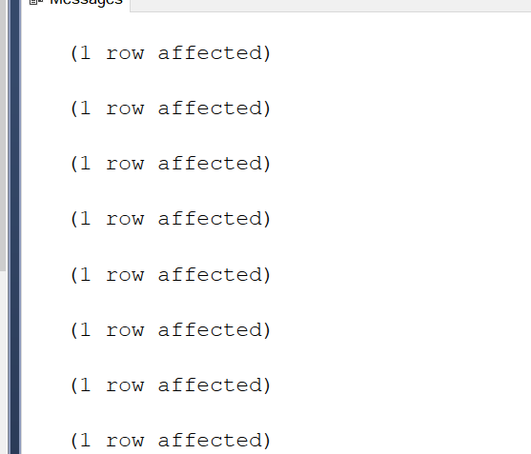

select\*from Ward

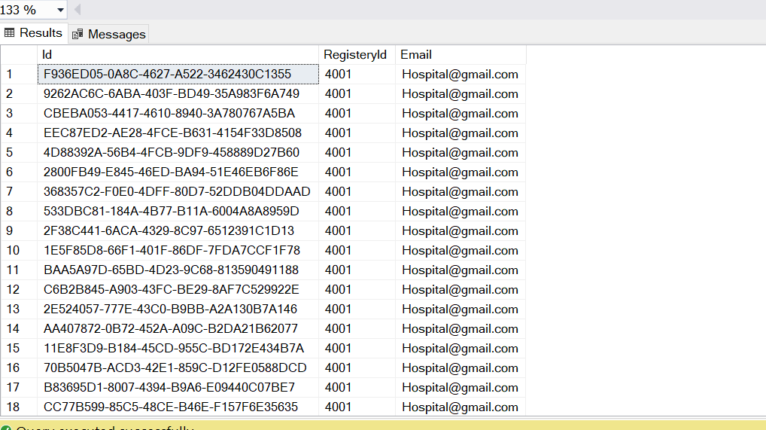

Go

create procedure spGetpatient

as

Begin

Select Name,email from Patient

End

go

exec spGetpatient

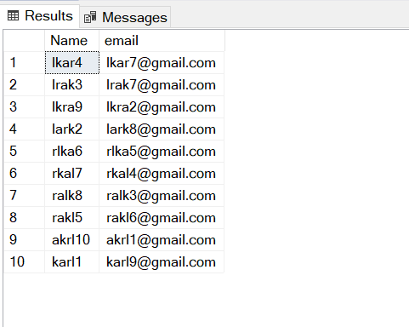

INSERT INTO Doctor values(newid(),'mark','kask','mark@gmail.com','kank2',190,291)

INSERT INTO Doctor values(newid(),'karm','kaks','karm@gmail.com','kank3',191,292)

INSERT INTO Doctor values(newid(),'armk','kkas','armk@gmail.com','kank4',192,293)

INSERT INTO Doctor values(newid(),'rmak','sakk','rmak@gmail.com','kank5',193,294)

INSERT INTO Doctor values(newid(),'ramk','skak','ramk@gmail.com','kank6',194,295)

INSERT INTO Doctor values(newid(),'kram','skka','kram@gmail.com','kank7',195,296)

INSERT INTO Doctor values(newid(),'kamr','askk','kamr@gmail.com','kank8',196,297)

INSERT INTO Doctor values(newid(),'rkma','aksk','rkma@gmail.com','kank9',197,298)

INSERT INTO Doctor values(newid(),'rakm','ksak','rakm@gmail.com','kank1',198,299)

INSERT INTO Doctor values(newid(),'arkm','aksa','arkm@gmail.com','kank10',199,300)

INSERT INTO patient values(newid(),'karl1','mänd1','karl9@gmail.com','lank23',1801)

INSERT INTO patient values(newid(),'lark2','mndä2','lark8@gmail.com','lank34',1811)

INSERT INTO patient values(newid(),'lrak3','mädn3','lrak7@gmail.com','lank74',1821)

INSERT INTO patient values(newid(),'lkar4','mnäd4','lkar7@gmail.com','lank57',1831)

INSERT INTO patient values(newid(),'rakl5','mdän5','rakl6@gmail.com','lank76',1841)

INSERT INTO patient values(newid(),'rlka6','ändm6','rlka5@gmail.com','lank77',1851)

INSERT INTO patient values(newid(),'rkal7','ädmn8','rkal4@gmail.com','lank88',1861)

INSERT INTO patient values(newid(),'ralk8','änmd7','ralk3@gmail.com','lank99',1871)

INSERT INTO patient values(newid(),'lkra9','nämd9','lkra2@gmail.com','lank19',1881)

INSERT INTO patient values(newid(),'akrl10','nädm10','akrl1@gmail.com','lank102',1891)

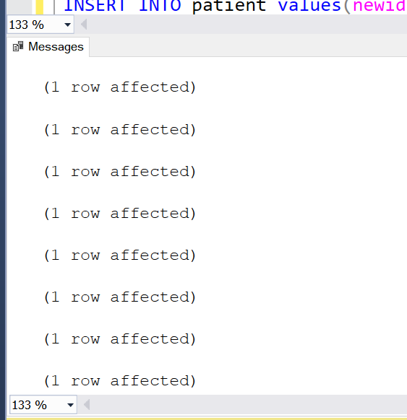

select\* from patient

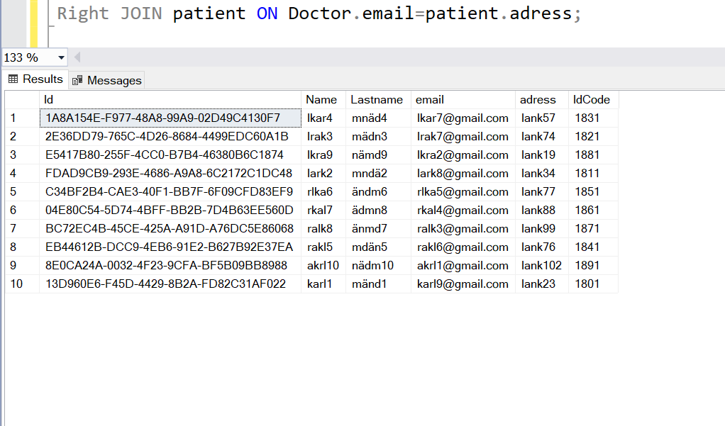

SELECT Doctor.Name, patient.adress, Doctor.adress

FROM Doctor

INNER JOIN patient ON Doctor.email=patient.adress;

SELECT Doctor.Name, patient.adress, Doctor.adress

FROM Doctor

Right JOIN patient ON Doctor.email=patient.adress;

SELECT Doctor.Name, patient.adress, Doctor.adress

FROM Doctor

Left JOIN patient ON Doctor.email=patient.adress;

